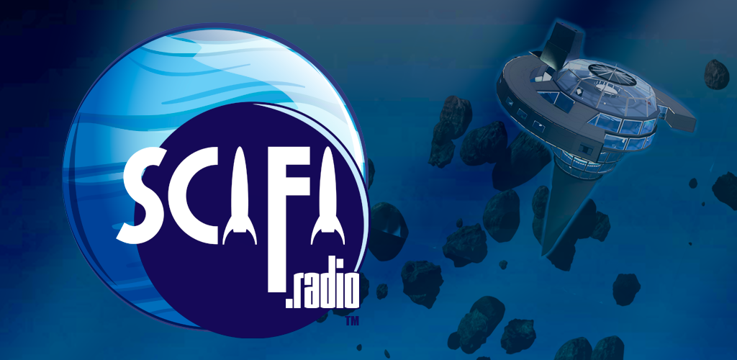
The radio station you've been waiting for all your life.
We're the highest quality, the oldest, and the best loved sci-fi fandom radio station on the entire planet. In operation since 2009, our listeners tune in via Stitcher, iTunes, TuneIn, Roku Radio, GetMeRadio, our own web site, via our free Amazon Alexa skill, or one of our free mobile apps for Android, and iOS devices.
We currently average 95,000 listener connections per month, in 218 countries around the world. This works out to a bit over 1 million listener connections per year (with the potential of more than one listener per connection), from roughly 170,000 unique addresses, making our listener base the size of a medium-sized city. Our listeners are about 65% male, 18-34, and our content is family friendly.
Get a station sponsorship, a show sponsorship, or order radio spots or web ads à la carte.

Station Sponsorships
Station sponsorships are for companies who are serious about brand building on the world's best sci-fi geek culture radio station.

Gold Level - $265 per month ( $4,800 / yr )
You get priority placement in all venues. You get two plays per hour of your radio spot around the clock for the month, one at the top of each hour and one at each half hour, and your leaderboard web ad will enjoy exclusive placement on the top of our web site. Your brand will also be mentioned on our social media.

Silver Level - $225 per month ( $3,900 / yr )
Your message is blasted across both our radio station and our website. You get one play per hour of your radio spot throughout the month, and will share one of the banner spots (could be top banner, big box or skyscraper - whatever is available) with other advertisers in rotation.

Bronze Level - $185 per month ( $1,620 / yr )
Choose either radio ads or a web ad. You get one play of your radio ad every hour through each month, plus your choice of a 125x125 square button ad on the bottom of the front page, or a 300x250 square button ad in the sidebar of the article pages for that month.

Show Sponsorships - $95 per month ( $1140 / yr )
Build brand recognition by being a continuing sponsor of one of our regularly scheduled radio programs. Your sponsorship announcement is read before and after each show episode, identifying both your product or service and your status as sponsor, and your radio ad is played at the beginning of each programmed hour for each program you sponsor.

Radio Spots
This may surprise you: radio ads are actually very cheap. A single color rack card costs more than a radio ad. We sell them by the play. Spots may run from 30 seconds to 60 seconds in length.
- 30 second spots are ~20.5¢ per play ($120 min. Order), or $150 per month
- 60 second spots are ~25.2¢ per play ($165 min. Order), or $185 per month
You specify once per two hours, one per hour, or twice per hour. With a minimum order, your ad will play once an hour for 30 days, or twice an hour for 15 days. You can order as many plays as you like.
Record spots as 16-bit stereo MP3 files, 64kbps-128kbps stream rate, 44100Hz sample rate. You're responsible for securing music rights if you make your own ad. We can record and produce it for you at no charge if you’re not comfortable doing that on your own. A 30s spot is about 80 words, so at minimum you’ll have to submit the text of the ad as you want it read on the air.

Restricted content
We do not accept advertising for the following:
- Political ads
- Smoking, vaping or drug related paraphernalia
- Content or products of a directly sexual nature
- Gambling, betting, or online casinos
- Ads that are libelous or defamatory toward any particular religious, racial, gender specific, ethnic or socioeconomic group.

We Do Not Offer Region-Specific Advertising
We currently have no way of delivering ads targeted to specific parts of the world to listeners or readers in those geographic regions. You can still advertise your brick and mortar store, but we remind you that the ad will go out to the entire planet with no way to target a specific geographical area.

Graphic Ads à la Carte
For some reason we get a really high click through rate compared to other kinds of web sites. Some advertisers report clickthrough as high as 3%, about double the average on web ads, and it’s because our visitors are extra focused on the genre and content we serve.
When you buy a web ad, you get that spot to yourself for the month. You don't have to share it in rotation with other ads.
Type | Location | Size in Pixels | Cost per Month
Top leaderboard | In header with SCIFI.radio logo | 728 x 90 | $115.00
Bottom leaderboard | below main body, above footer | 728 x 90 | $95.00
Skyscraper | left sidebar (appears only on article pages, not the main page) | 160 x 600 | $85.00
Sidebar Ad Button Row | Left sidebar buttons (appears only on article pages, not the main page) | 320 x 250 | $65.00
Bottom Ad Button Row | Below main body, above footer | 125 x 125 | $55.00
Please contact SCIFI.radio at advertising@scifi.radio and we'll help you get started. Rates and policies listed effective June 3, 2022, superseding any previously published. Prices subject to change without notice. Krypton Radio is a service of Krypton Media Group, Inc., 13636 Ventura Blvd, Suite 338 Sherman Oaks, CA 91432

